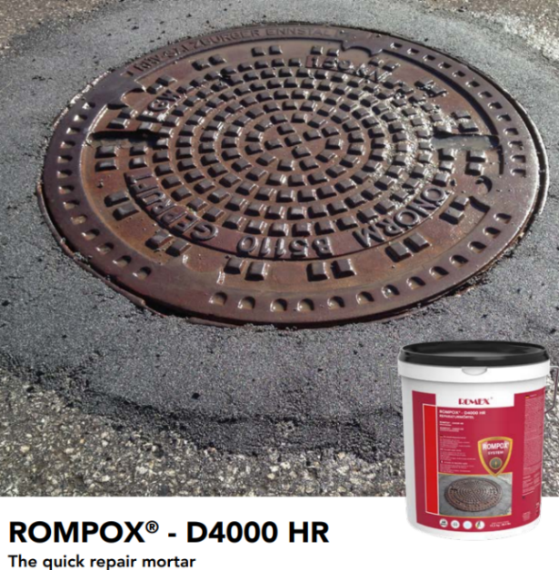

ROMPOX® - D4000 HR is a 2-component epoxy resin repair mortar. This mortar is used for friction locked crack sealing and to repair edges or broken areas. Thanks to the high reactivity of the product, the surface can be re-opened to traffic very quickly. An application temperature of up to -10 °C | 14 °F makes this product unique. Whether for road damage, holes, breakage on curbs or around manhole covers or cracks in floor coatings: the unique repair mortar ROMPOX® - D4000 HR can be used all year round, even at minus temperatures.
Consumption Rates:
Contents: 2.5 lbs resin + 2.5 lbs of hardener + 40 lbs of sand
Features and Benefits
• for the repair of edges/broken areas
• for surface depths from 10 mm | 3 ⁄8“
• weed & ant resistant
• high strength
• for friction locked pouring of cracks
• for treatment of sinkholes and faulty areas
• quick re-opening to traffic
Pricing (Inc Sand):
Contractor - $221.26 / Retail - $244.18

Technical Data
System
Compressive Strength | 51.2 N/mm2 – 7426psi Building Site Value | DIN 1164 part 7
Bending Tensile Strength | 19.4 N/mm2 – 2,814psi Building Site Value | DIN 1164 part 7
Static Elasticity Module | 8900 N/mm2 – 1,290,836psi Building Site Value | DIN 1164 part 7
Hard Mortar Raw Density | 1.73 Kg/dm3 – 1.0 oz/in3 Building site value
Application Time @ 20c / 68f | 10-15 Minutes | Romex -norm 04
Application Temperature | -10c/30f up to 30c/86f at lower temps. Hardening slows. Higher temps. speeds hardening
Re-opening of surface @ 20c/68f | Can be walked on in 2 hours
Shelf Life | 24 Months, Frost Free
Romex D4000 Consumption Chart | D4000 resin + 40 lbs of sand = .4 cubic feet
Depth | Coverage
3/8” | 12.8 sqft
½” | 9.6 sqft
5/8” | 7.68 sqft
¾” | 6.4 sqft
7/8” | 5.48 sqft
1” | 4.8 sqft
1 1/4” | 3.84 sqft
1 ½” | 3.2 sqft
1 3/4” | 2.74 sqft
2” | 2.4 sqft
2 ½” | 1.92 sqft
3” | 1.6 sqft
4” | 1.2 sqft
6” | 0.8 sqft

